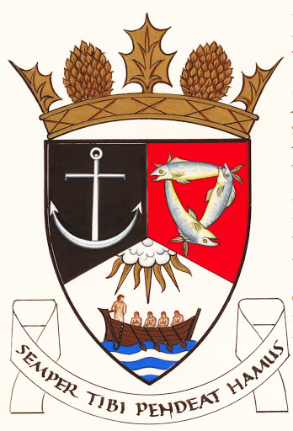

The Royal Burgh of Kilrenny, Anstruther and Cellardyke Community Council
Skatepark Sub Committee
Meeting 1st December 2022
Minutes
Present: Andy Peddie ( chair ), Martin Dibley ( minutes ) Ellis Jaffray, Alan Nairn, Ben Black, Alan Ballany, Suzanne McElhinney( standing in for Sarah Hughes ), Sarah Rogerson, Linsey McKinstry, Janice Fyall, Murray Scott, Bjorn Lie.
Apologies: Cllr Sean Dillon, Cllr Alycia Haynes.

Andy welcomed everyone to the meeting especially two new members, also Suzanne who came with five minutes' notice and Martin who will take minutes.
The purpose of the meeting was to look at the identified sites and access their suitability again the criteria of size, site ownership and access

- Members of the skatepark group gave a presentation that showed each site, the available area within the site ( i.e. over 50m from residential properties ) and an indicative size skatepark of the equivalent of 20 m square. The suitability of each site was then discussed.

Silverdykes. While there is just enough space for a skatepark the land is managed by Ross and Liddel on behalf of the 312 property owners of Silverdykes. They would have to give unanimous support to proceed on this site. It was therefore agreed not to take this site any further.
Dreelside. When you take out the 50m rule the only part of the park available is on the football pitch and no one wants to remove this facility. This view was supported by the Dreelside group. It was therefore agreed not to take this site any further.
West Braes Pittenweem. There is room on this site and the land is owned by Fife Council . However, there is a question mark over the availability of the section 75 monies. Andy will investigate. It was noted that this is a pittenweem common good fund area. It was noted that this is not a problem but one that needs clarifying if this site is to be the preferred one. The skatepark group noted that there are access and other issues with this site and the group's stated aim is to develop a site in Anstruther. Community Council noted that this site is outwith their jurisdiction if it was to be the preferred site.
Waid. There is the space, however, the land is owned by Sodexo under a PPI contract until 2028, so a discussion needs to take place on possible availability. There was a further discussion on alleged proposed allotments in the same area, Andy to investigate
Bankie Park. Yes, there is the space and Fife Council owns the land. However to comply with the 50m rule the football pitch will need moving, opening up other questions on the available space and other uses.

- The skatepark group then showed a presentation of a skatepark that is going ahead in North Berwick at a cost of £150,000 which gave the committee a rough idea of what could be achieved in the East Neuk.

- The question of lighting was raised. The Skatepark group made it clear that lighting was not part of this plan. If more funds could be raised they would be used to obtain better facilities not to add in lighting. Lighting could be a future project for the group once the skatepark is up and running.

- The question of planning permission was raised. It was said that this project would not require planning permission as it was considered permitted development.

Action points:

Person Action point
Andy | Investigate section 75 monies
Skatepark group | Land availability at Waid
Andy | Allotments.

Date of next meeting: it was agreed to look at a date in late January when some of our councillors could attend.

