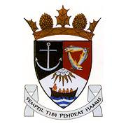
THE ROYAL BURGH OF KILRENNY, ANSTRUTHER & CELLARDYKE COMMUNITY COUNCIL MEETING 13TH MAY 2019
7.30PM AT THE EAST NEUK CENTRE
A G E N D A
- Welcome & Apologies
- Declaration of interest
- Approval of Minutes & Matters Arising
- Input from East Neuk Emergency Trust
- Input from Community Police
- Questions from the public
- Secretaries Report
- Treasurers Report
- Councillor’s Report
10.Fife Council Street Naming N_19023
11.Website & Communication
12.Harbour Festival Funds
- Common Good Fund
- Fund request to CC
- CC Fundraising
12.Adopt A Phonebox Scheme
13. 5G in Fife
14. Dreel Burn Project
15. Feedback from other groups
i) Floral
ii) SLC
- Multi Use Path
- Murray Library Trust
- Harbour Issues
16. AOCB

CLOSE OF MEETING FOR PUBLIC

17. Citizen of the Year
18. AOCB

