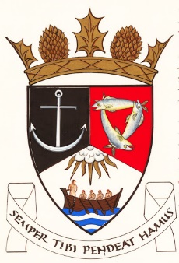
THE ROYAL BURGH OF KILRENNY, ANSTRUTHER & CELLARDYKE COMMUNITY COUNCIL
Monday 12 June 2023 7:30pm IN The BURGH CHambers

A G E N D A

- Welcome & Declarations of Interest
- Approval of Minutes & Matters Arising
- Questions from the public
- Planning/Licensing Matters
- Community Council Elections

- Crawhill Woods
- Secretary’s Report
- Treasurer’s Report
- Councillor’s Report
- Representation from other groups
- Floral Group
- Murray Library Trustees
- AOCB

